2024 APPLICATION FOR ADMISSION & ENROLLMENT AGREEMENT
Youth Program

SECTION A: SESSION INFORMATION

Please select the session(s) below that you would like your child to attend. He or she may attend more than one session.

 | 3 Week Program
Session 1
Starts | June 24
Ends | July 12
Session 2
Starts | July 15
Ends | August 2

Total number of sessions that he/she will attend:

SECTION B: PERSONAL INFORMATION
1) Student Name:
(Last/Family Name) (First/Given Name) (Middle Initial)
2) Date of Birth: ________________/_______/______ 3) Gender: Male Female
Please write month. Example: “January” Month Day Year
Must be born before June 1st 2002
4) City & Country of Birth: 5) Country of Citizenship:
6) Address in home country:
(Number) (Street Address) (Apt. No.)

(City) (State/Province) (Postal Code) (Country)

(Telephone No.) (Email Address)

7) Parent/Legal Guardian Information:
Parent/Guardian 1:
(Last/Family Name) (First/Given Name) (Middle Initial)
Email address: Phone number:

Parent/Guardian 2:
(Last/Family Name) (First/Given Name) (Middle Initial)

Email address: Phone number:

8) In case of emergency please list a contact person:

Name Relationship Phone Number (include country and city code if not in the U.S.)
Email address:

9) Allergies:
Does your child have any allergies? If so, please list below (food, medicine, insect stings, etc.)

10) Additional information
Please provide any additional information you’d like us to know about your child.

SECTION C: POLICIES

Attached to this Application you will find the Mentora College (Mentora) Youth School Student Handbook. Please read it very carefully before signing this binding agreement with us. It contains our Cancellation and Refund Policy, which is in full compliance with Title 5-A8119 of the D.C. Regulations governing Postsecondary Non-Degree Schools. You will also find our School Policies (Rules and Regulations) as well as USCIS/SEVIS Policies governing Visa.

By my signature below, I give my permission to Mentora to use my child’s likeness (in still photography and or video) in school promotional materials: such as print, internet, video, commercials, or other similar media. I do not expect to be compensated in any way for such use and I release all future rights to the images.
This Enrollment Agreement becomes a legally binding contract between Mentora and the guardian, unless cancelled under the terms of the Mentora Cancellation and Refund Policy mentioned above. I agree that my child will follow Mentora Policies, Rules and Regulations as described in the Mentora School Catalog and Student Handbook. I have been advised to read those and any other documents very carefully and to have them translated into my native language, if necessary, before signing this Agreement. By signing here, I fully agree with all the terms and conditions stated on all policies.

Parent/Guardian Signature**: Date:
** If a student is NOT of legal age (18 years old) only the parents, the sponsor, a legal guardian or an adult in charge of submitting this Application can sign this Agreement. In that event, that party agrees to be responsible for fulfilling all terms and conditions of this Agreement.

SECTION D: PLACEMENT
The purpose of this section is to understand how much exposure the student has had to the English language prior to coming to Mentora College’s Youth Program.
Please complete this section with the student.
1. I can: Well OK Not well
Read English ☐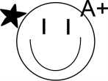 ☐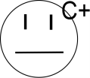 ☐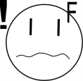
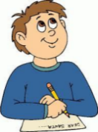Write in English ☐ ☐ ☐
Listen to English ☐ ☐ ☐
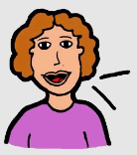Speak English ☐ ☐ ☐

2. I started English when I was:
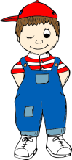☐ 0-11 years old 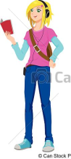☐ 12-17 years old

3. I like to:
☐Watch TV and movies ☐Listen to music ☐Read books ☐Talk to people 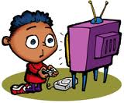☐Play video games 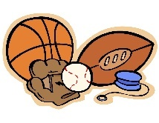☐Play sports
4. Writing Sample
- Choose one of the topics. Answer the questions.
Topic 1: My Favorite Things. Answer the questions about three favorite things.
What are your favorite things? Why do you like them?
1.
2.
3.

Topic 2: An Interesting Place to Visit. Answer the questions about an interesting place in your town or city.
Where do you live?
What’s the most interesting place there?
What kind of place is it?
What can you do there?
Why should visitors go there?

- Now use your answers in Part A to write about the topic.
Topic:
_____________________________________________________________________________________
_____________________________________________________________________________________
_____________________________________________________________________________________
_____________________________________________________________________________________
_____________________________________________________________________________________
_____________________________________________________________________________________
_____________________________________________________________________________________
_____________________________________________________________________________________
_____________________________________________________________________________________
_____________________________________________________________________________________

