REOPENING PLAN FOR FALL 2020
Prepared for HELC
SUBMITTED ON JULY 15, 2020

TABLE OF CONTENTS
 | Page
EXECUTIVE SUMMARY | 3
PREVENTIVE MEASURES | 6
COMMUNICATION WITH STUDENTS, FACULTY AND STAFF | 6
REOPENING BUILDINGS | 6
PHYSICAL DISTANCING | 6
DAILY HEALTH SCREENING | 9
NON-MEDICAL (CLOTH) FACE COVERINGS | 9
HYGIENE | 9
CLEANING, DISINFECTION, AND SANITIZATION | 10
HIGH-RISK INDIVIDUALS | 10
MEALS | 11
RESPONSE ACTIONS | 12
EXCLUSION AND DISMISSAL CRITERIA | 12
EXPOSURE REPORTING, NOTIFICATIONS, AND DISINFECTION | 13
APPENDIX A COVID-19 CAMPUS HEALTH AND WELL-BEING DRAFT POLICY | 15
APPENDIX B EXAMPLES OF INFORMATIVE POSTERS | 18
APPENDIX C COVID-19 HEALTH SCREENING FORM | 25

EXECUTIVE SUMMARY

Bay Atlantic University is currently closed due to the pandemic. As we began to re-open, we will follow the guideline set forth by the office of Mayor Muriel Bowser and the Center for Disease Control and Prevention (CDC).

BAU has established a Reopening Committee with the following members and worked on the Reopening Plan through May 27, 2020 to present day:

Dr. Sinem Vatanartiran, President
Melek Edib, CFO
Dr. Billur Cohen, Dean of Academics
Angela Myers, Human Resources Director
Koray Bintas, Teacher
Taylor W. Nickels, Head Librarian
Amgaa Tserenchimed, Administrative Director for Mentora
Khaliun Nyamdavaa, Executive Secretary to the President

Our priority is to maintain a healthy and safe teaching, learning, and work environment for our students, faculty, and staff. The reopening committee number one priority is to ensure that all safety protocols are received and implemented to stop the spread of COVID 19. The efforts include two primary dimensions: academic planning and operations:

ACADEMIC PLANNING
Task: Prepare BAU’s academic enterprises for a return to in-person operations for the fall semester and propose plans for necessary adjustments to teaching and learning and student support. Additionally, prepare for contingencies in the academics should it not be safe to return, in part or in full, to on-campus operations in the fall semester.
Team Leader: Dr. Billur Cohen, Dean of Academics

OPERATIONS
Task: Prepare BAU’s campus operations for a return to in-person instruction and a residential academic experience for the fall semester, focusing specifically on health and well-being, support services, campus events and activities, and campus spaces. Additionally, prepare for contingencies in operations should it not be safe to return, in part or in full, to on-campus operations in the fall semester.
Team Leader: Angela Myers, HR Director
Bay Atlantic University will re-open in two phases:

First phase: July 15th, Administration and executive offices will return to the building
Second phase: August 25th, Bay Atlantic University will welcome all students, faculty, executive offices, and aids.

Physical distancing will be enforced by modifying staff and class schedules, following the classrooms' capacity limits, removing seating from computer labs, library, posting signs to follow distancing rules, and proper hygiene throughout the building.

BAU plans to begin in-person instruction on Aug. 31. However, we are planning to offer a few courses online. These would be the courses that we expect to have more than 15 enrollments. The Academic Dean is now working with the Program Chairs to identify such courses. We anticipate a modified fall semester that would end on-campus instruction at Thanksgiving break and include two weeks of remote instruction afterward to reduce the risk to the community from students traveling during Thanksgiving break and then returning to campus. We also plan to hold classes on Labor Day to encourage students to remain on campus and all staff and students to avoid travel during the extended weekend.
FALL 2020: 15 weeks (August 31- December 19, 2020)
Fall Term Advising Period | August 3 – August 30
Registration for Fall 2020 | August 17 – August 31
New Students Orientation | August 27
First Day of Classes | August 31
Last Day of Add/Drop Period | September 11
Mid-Semester Evaluation Survey | October 15-30
Withdrawal Deadline | October 23
Thanksgiving Break (BAU CLOSED) | November 25– November 27
Final Week of Classes (Exam Week) | December 14 – December 19
Grades due by Faculty | December 21
End of Semester Evaluation Survey | December 21
Incomplete Grade Change Due by Registrar | January 18
*** No classes | December 08
In addition to the modifications in the academic calendar, before students return to campus, BAU is taking many steps to ensure that academic spaces are safe and expectations about social distancing and appropriate behavior are clear. BAU will require everyone on campus to wear a cloth mask when in public areas or in the presence of others, practice social distancing, and follow CDC recommendations for handwashing and coughing/sneezing hygiene. Protocols and procedures will be regularly assessed to ensure agreement with current policies set forth by the Centers for Disease Control and Prevention and the D.C. Department of Health. The necessary information will be shared with all BAU members via emailing, website announcements, and visible informative posters.

Students, faculty, and staff will be expected to pledge that they will adhere to required health and safety guidelines established by the university and the District of Columbia. This public health pledge will reinforce personal and community responsibility to create a safe and healthy environment. (See Appendix A for the COVID-19 Campus Health and Well-Being draft policy.)

The university will carefully monitor its capacity for quarantining and isolating students, for doing on-campus COVID-19 campus case contact investigations, and for providing students and employees health surveillance. BAU will take action to move to increase online instruction and telework if there is a large resurgence on campus.
BAU will be prepared at any time for virtual instruction and will, of course, be prepared at any time to comply with any and all D.C. requirements that may shift as the pandemic evolves.

The details of the preventive measures and the response actions are explained in the following sections of the Reopening Plan.

PREVENTIVE MEASURES

COMMUNICATION WITH STUDENTS, FACULTY AND STAFF
BAU has prepared signs to be posted in highly visible locations (e.g., facility entrances, hallways, elevators, elevator doors, restrooms) that promote everyday protective measures and describe how to stop the spread of germs (See Appendix B). Signs also indicate room and elevator capacities with social distancing, one-way directions for stairways and hallways, and provide floor marks to show people where to stand and sit.

Since the start of the pandemic, we have been using our website (www.bau.edu), social media accounts (Twitter, Facebook, Instagram), and direct group emailing to educate all our students, faculty, and staff about the updates on the pandemic and the actions we take. We will continue to do so during the Fall Semester.

COVID-19 Point of Contact (POC): Angela Myers, HR Director, amyers@bau.edu, phone (202)644-7200 ext. 5076. The POC will be responsible for screening employees for COVID 19 exposure, notify if a student or staff member tests positive for COVID-19 and be responsible for ensuring the appropriate steps are followed in the event of a confirmed case of COVID-19 (See section L).

Human resources office will meet one on one to educate the staff on best practice and correct ways to clean, wear PPE, and discard of those items.

REOPENING BUILDINGS
Since our campus is located in the White House area, the windows of our building cannot be opened. However, we have been working with the Lincoln Property, LLC that manages our building to prepare the campus for the reopening. All ventilation systems and flush water systems have been checked regularly since mid-June.

PHYSICAL (SOCIAL) DISTANCING

Entering and Exiting School
As employees and students return to the campus for the very first time, they will be greeted and screened for COVID 19 symptoms by a designated person from the re-opening committee. All employees and students entering the building will complete a questionnaire about their current health conditions and have their temperature taken using an infrared thermometer. Anyone entering the building will be reminded to have their face masks on. If they do not have a mask, one will be provided.

Students, faculty and staff will be asked about whether the student or staff member has experienced the following symptoms consistent with COVID-19 (See Appendix C for Covid-19 Health Screening Form):

  - Fever (subjective or 100.4 degrees Fahrenheit) or chills
  - Cough
  - Congestion
  - Sore throat
  - Shortness of breath or difficulty breathing
  - Diarrhea
  - Nausea or vomiting
  - Fatigue
  - Headache
  - Muscle or body aches
  - New loss of taste or smell
  - Or otherwise feeling unwell.

Students, faculty and staff should be asked if they have been in close contact with a person who has COVID-19.

The COVID symptom forms will be kept locked in a secured office. Employees and students entering the building will not proceed further until this two-task is complete. Mask will be required and provided for those who do not have one. If any person refuses these procedures, they will need to leave and only to return once they can comply with the new systems.

We will use both doors (the BAU/Mentora Door and the Building Main Door) for entry and exit to avoid funneling all students through a single point of entry.

We have created clear space delineations for areas where students may be required to wait in lines like elevators, main info desk, and such.

Use of Indoor Space
BAU will have in-person staff meetings with no more than 6 people in the 4th Floor Meeting Room, 8 people in the 7th Floor Meeting Room, and 12 people in the 8th Floor Meeting Room. Staff meetings with more than 12 people will be conducted online.

BAU will close the Student Union to avoid students socializing together in large numbers. However, It will be used as a large classroom space to host classes with 20 to 35 students.
We have rearranged all classrooms to ensure six feet between students and turned desks to face in the same direction (rather than facing each other) to reduce transmission caused by virus-containing droplets (e.g., from talking, coughing, sneezing).

Students will be allowed to take breaks in their classrooms rather than mixing in the lounge areas.

The teacher will be responsible for enforcing the mask in the classrooms and ensuring students maintain a 6 feet separation from one another. Seats will be removed or taped to avoid sitting in to help with enforcing six feet separation.

Teachers will have hand sanitizers for their classroom and EPA disinfecting wipes/sprays available. Students will be required to wipe down their desks at the end of their class.

Faculty and advisers will be encouraged to use online office hours where possible.

BAU will also modify class attendance policies to ensure that faculty and students stay home if they show any signs of illness.

For the staff, offices are re-arranged allowing 6-feet distance between two desks. Some staff who are sharing small offices at the moment will be designated new offices.

Canceling, Eliminating or Modifying Activities
The Academic Departments have cancelled all large in-person group activities and field trips. Students will be encouraged to attend online events like webinars for field trips.

All social activities for employees are cancelled (like the Tuesday lunches, Happy Fridays, birthday celebrations, and Admin Fridays).
BAU is committed to minimizing travel outside the national capital region (NCR). Any university-affiliated travel that is believed to be essential will be subject to approval from the relevant dean or the President during the fall 2020 semester. Travel by faculty or staff is not essential if it can be postponed or managed by alternative methods, such as electronically. Professional or educational conferences are defined as non-essential travel.

DAILY HEALTH SCREENING

The university is developing the means to enable daily symptom self-screening for students, faculty and staff.
BAU will perform a daily health screen for all students, faculty and staff entering the building by taking their temperature. Any student, faculty, or staff member with a temperature of 100.4 or higher shall not be admitted and shall be instructed to call their health care provider to determine the next steps.

The staff will also visually inspect each student, faculty and staff member for signs of illness which could include flushed cheeks, rapid breathing or difficulty breathing (without recent physical activity).

Should an employee develop respiratory issues and or fever during the day; they will be immediately removed to an isolated area if they are in a shared space. Employees will be sent home and asked to monitor their symptoms and contact their doctor if their symptoms worsen or if they are concerned. The areas of that individual will be off-limits for 24 hours, then cleaned and disinfected using EPA approved chemicals and CDC recommendations on cleaning procedures.

NON-MEDICAL (CLOTH) FACE COVERINGS (FACE MASKS)
Everyone entering the building will be required to have cloth face coverings or PPEs and to keep it on during their stay in the building.

Students, teachers and staff will be directed to speak more loudly, rather than remove their face covering, if speaking in a noisy environment.

Instances when face coverings do not need to or should not be worn:
By anyone who has trouble breathing, or anyone unconscious or unable to remove the mask without assistance.

Any staff, student or faculty member that cannot wear a mask, face-covering or face shield due to medical condition will need to provide a doctor’s note to HR. Students will need to give a letter to the dean of students to excuse them from mask requirements. Students who unable to wear a face mask or face coverings will have a partition around their desk.

HYGIENE

Hand Hygiene
BAU has already purchased in bulk hand hygiene and surface disinfectants with at least 70 percent alcohol. Each teacher is given a set of hand hygiene and surface disinfectant. Teachers will spray each desk, chair, computer keyboard, remote control, door handles and A/C command box at the end of their session.

We have removed all shared supplies from teacher desks and office desks. With the help of the informative posters in the classrooms, students will be asked to use their own supplies.

Schoolwide Hygiene
There will be a hand hygiene station on each floor. Restrooms are cleaned and disinfected at the end of each day. The whole school will be disinfected by a professional company every 2 weeks.

Students and staff are encouraged to bring their own water bottles and to avoid touching or utilizing water fountains. There will be disinfectant wipes and spray in the kitchenettes for staff to use after using the appliances or touching surfaces.

  - CLEANING, DISINFECTION, AND SANITIZATION
BAU will meet or exceed CDC guidelines for cleaning in classrooms, study spaces, and public spaces, with a special focus on high-touch surfaces. Cleaning supplies, including hand sanitizer and disinfecting wipe dispensers, will be provided in high-traffic areas to allow self-service cleaning. We are also creating one-directional stairways and hallways; and limiting the maximum capacity for elevators, classrooms and other common spaces. We are using bulk procurement of PPE and sanitizing supplies to ensure we can meet the needs of our community.

The procurement office will do a triweekly inventory to ensure the school has adequate supplies in stock to maintain healthy hygienic practices and regular cleaning of the school facility. Supplies will be distributed by the procurement office as needed to the classroom and offices.

  - HIGH-RISK INDIVIDUALS
The university is making accommodations for high-risk individuals to teach and attend classes and, where feasible, work remotely. As outlined by the D.C. Department of Health and the CDC, these include but are not limited to individuals with chronic lung disease, moderate to severe asthma, serious health conditions, immunocompromised conditions, severe obesity, diabetes, chronic kidney disease and liver disease and those who are over the age of 65.

BAU is giving students with high-risk the option to attend virtually. According to the guidelines set by the Mayor, all individuals considered high-risk must inform Human Resources so it can be recorded and receive a health clearance from their physician before returning to the building.

  - MEALS
BAU will close the Student Union to avoid large gatherings in number. All students will be encouraged to have their meals in their own classrooms. Teachers will be encouraged to have their meals either in their own classrooms or in the teacher lounge with no more than 4 people sitting at once.

All staff will have their meals at their own desks. There will be no gatherings for lunch.

RESPONSE ACTIONS

  - EXCLUSION AND DISMISSAL CRITERIA
Employees and/or students with pre-existing health conditions that present with specific COVID-19 – like symptoms may not be excluded from entering the school building on the basis of those specific symptoms, if previously evaluated by a health care provider and those specific symptoms determined to not be due to COVID-19.

Exclusion Criteria:
Students, faculty and staff will be required to stay home, and not be admitted to the campus, if:
- The student, faculty or staff member has had a temperature of 100.4 degrees or higher or any of the symptoms listed in Section C, Entering and Exiting School of this guidance.
- The student, faculty, staff member or any close contact is confirmed to have COVID-19.
- The student, faculty or staff member is awaiting COVID-19 test results.

If a student, faculty or staff member reports any of these specified symptoms, or is confirmed to have COVID-19, the student, faculty or staff member will be required to not return to school until:
- They complete the appropriate isolation period:
  - 72 hours after the fever has resolved without the use of fever-reducing medication (e.g., Motrin, Tylenol) and respiratory symptoms have improved; AND
  - At least ten days after symptoms first appeared, whichever is later; OR
- They have a negative COVID-19 test, and meet standard criteria to return to school after an illness; OR
- They have been cleared from isolation per their healthcare provider or DC Health instructions.

If any student, faculty or staff member has been in close contact with a person who is positive for COVID-19, then the student or staff member must not enter the facility until cleared by their healthcare provider or have completed their quarantine period of 14 days from the last day of close contact with the COVID-19 positive individual without becoming symptomatic or diagnosed with COVID-19.

If any student, faculty or staff member is awaiting a COVID-19 test result, then the student, faculty or staff member must not enter the facility until they test negative and meet standard criteria to return to school after an illness. If they test positive, then they should immediately begin a self-quarantine and seek further guidance from their healthcare provider or DC Health.

Dismissal Criteria:
If a student, faculty or staff member develops a fever or other signs of illness, the POC will send the student/faculty/staff member home immediately, or isolate until it is safe to go home and seek healthcare provider guidance and follow cleaning and disinfecting procedures.

If an employee has tested positive for COVID 19 and shows symptoms of COVID, the employee will be required to self-quarantine based on the CDC's recommendation and guidance from a medical professional. If an employee had exposure to a person tested positive for COVID 19, the employee would be required to self-isolate per CDC recommendation under the care of a physician.

A full-time employee is eligible to use sick leave, DC paid leave and/or vacation if necessary. If the employee requires additional leave they can review their eligibility with human resources for FMLA. Part-time employees can speak with human resources to review the options for leave.

An employee who has an absence for three consecutive workdays due to illness must present documentation from their physician to the human resources department or their immediate supervisor.

If the employee is absent unexpectedly due to personal or a family member's illness, the employee should notify his or her supervisor or the director of human resources as soon as reasonably possible.

An employee who suffered from COVID can return to work once they have tested negative for COVID or have clearance by a physician and are no longer contiguous to others. The employee must follow all new rules and policies set by Bay Atlantic University.

If a teacher falls ill and cannot continue during the semester, a substitute will teach for the remainder of that time.

  - EXPOSURE REPORTING, NOTIFICATIONS, & DISINFECTION

Step 1: Reporting to DC Health
In the event that we identify a student, faculty or staff member who has tested COVID-19 positive, we will notify DC Health by emailing coronavirus@dc.gov with the following information:
- “COVID-19 Consult” in the email subject line
- Name and direct phone number of the best point of contact for DC Health to return the call
- Short summary of incident/situation
- An investigator from DC Health will follow-up within 24 hours to all appropriately submitted email notifications. Decisions on the timeline of exclusion and any other responses to a COVID-19 exposure will be determined by DC Health.

Step 2: Communication to Students, Faculty, and Staff
Should an employee or student contract COVID-19 and expose others in our workplace, the POC will immediately inform all employees and students of the possible exposure. Those employees who have been in direct contact with the infected individual will notified privately and be sent home and asked to telework for 14 days. Those students will be sent home and asked not to come back for 14 days, continuing their classes online and the dean will notify students and professors of the suspected exposure or infections of a student or professor.

Step 3: Cleaning, Sanitization, and Disinfection of Affected Spaces
In the event of a confirmed COVID-19 case in a student, faculty or staff member, a thorough cleaning of the infected individual's workspace will resume after the area has been closed off for at least 24 hours.

APPENDIX A

COVID-19 CAMPUS HEALTH & WELLBEING POLICY
Responsible University Official: The Person of Contact for COVID-19
Responsible Office: Human Resources
Last Reviewed Date: June 14, 2020

Policy Summary
Bay Atlantic University is committed to maintaining a healthy and safe environment for the BAU campus community to the greatest extent possible. This policy is rooted in our BAU values and service priorities, primarily the safety and care of the BAU Community as we evolve back to an in-person campus experience in an on-going pandemic environment. Although BAU cannot guarantee zero cases of the COVID-19 disease on campus, this policy is focused on COVID-19 disease prevention, infection control and mitigation following federal and local public health guidance and the university’s best judgment on reasonable and appropriate public safety measures.
This policy informs members of the BAU Community of our shared responsibility in the prevention, infection control, and mitigation of the COVID-19 disease to protect the health and safety of the BAU Community.
The knowledge and understanding of the COVID-19 disease continue to evolve and this policy, procedures, and other guidance and resources will be modified and updated as needed. Up to date information can be found on BAU’s website: www.bau.edu

Related Regulations
This policy and accompanying procedures are aligned and consistent with local orders and directives from the Phased Reopening guidelines that have been issued to date by the District of Columbia, the Commonwealth of Virginia, and the State of Maryland, as applicable. They are also consistent with the Centers for Disease Control and Prevention (CDC) guidelines and other recommendations by various federal government agencies, D.C., Virginia and Maryland Departments of Health.

Who is Governed by this Policy
Faculty, staff, students, volunteers, visitors, and contractors (“BAU Community”).

Policy
The purpose of this policy is to reasonably reduce the risks associated with operating BAU’s academic and operational activities within the evolving pandemic environment while at the same time respecting individual circumstances and needs. The university is committed to protecting the health and wellbeing of the BAU campus community to the greatest extent possible through the implementation of preventive measures, infection control, and mitigation activities. Members of the BAU Community also have a responsibility to foster a safe environment and are expected to adhere to and participate in all aspects of the policy and accompanying procedures.

Specifically, members of the BAU Community will be required to self-monitor for disease symptoms, practice personal safety and health practices, adhere to all posted signage and campus directives, and provide immunization and vaccine records as requested, subject to exceptions related to medical conditions and religious beliefs. Members of the BAU Community will also be required to comply with the infection control and mitigation protocols of the university, including testing, contact tracing, isolating and quarantining, if directed by university officials. Please see the accompanying COVID-19 Campus Health and Wellbeing Procedures for additional details and processes for requesting accommodations and exceptions.

Additionally, members of the BAU Community are expected to comply with the requirements of local jurisdiction related to reopening phases and protocols, as well as the university’s reopening plan. The university’s Point of Contact will provide critical safety and security information and directions regarding the public health status of the campus. More information regarding the University’s Reopening Plan can be found at [resource link TBD].

The day-to-day compliance with the requirements set forth in this policy and procedures will take effort, commitment, cooperation, respect and understanding by all members of the community. Protecting the health and safety of the BAU Community will require individual responsibility as well as fostering accountability in the people around us. Those who observe violations of these expectations are encouraged, but not required, to address the behavior directly if it is safe to do so through direct communication with the involved individuals. Through empathy, respect, kindness and collaboration we can hold ourselves and each other accountable to the health and safety standards outlined in this policy and procedures.

Compliance with this policy and its procedures is expected of all individuals on- campus. Non-compliance with any of the requirements of this policy and procedures may result in removal from campus until compliance is achieved, as well as potential disciplinary action. Reports of non-compliance with this policy may be made in a number of ways:
  - Alleged violations of this policy and procedures by a student or student organization should be reported to the Office of Student Services at aroset@bau.edu.
  - Alleged violations of this policy and procedures by a faculty member should be reported to the Dean of Academics at bcohen@bau.edu.
  - Alleged violations of this policy and procedures by a staff member should be reported to the HR Director at amyers@bau.edu.
  - If you are unsure about the role of the individual engaging in non- compliance you may make a report to the Point of Contact at amyers@bau.edu

Procedures
COVID-19 Campus Health and Wellbeing Procedures (TBD after the approval of our Reopening Plan by HELC)

APPENDIX B - EXAMPLES OF INFORMATIVE POSTERS AND SIGNAGES
Practicing social distancing.
This computer
is

Elevator
Social Distancing

Use Stairs If Possible, Located to the
Left and Right of The Elevator
Maintain 6 Feet Separation
Always Wear A Mask
Thank you for cooperating

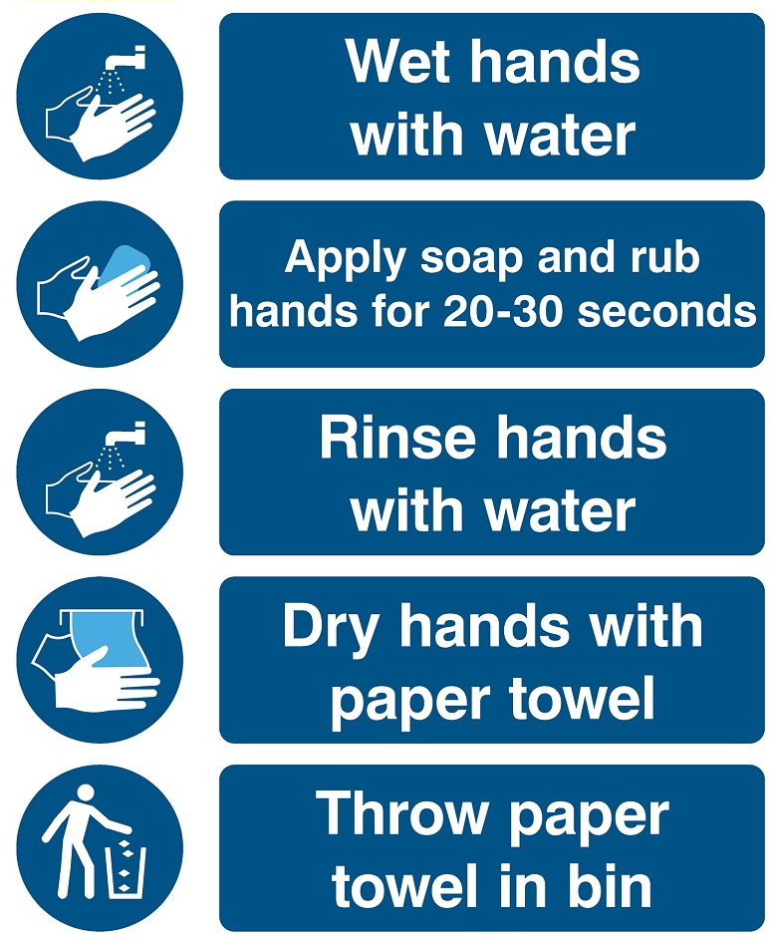
Hand washing instructions

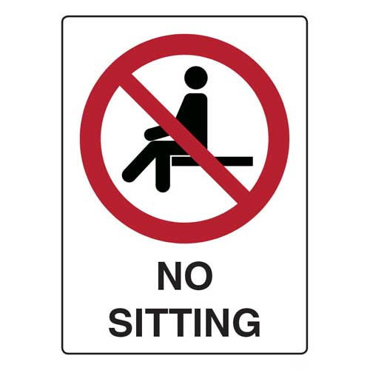
For your health and ours

Thank you for your cooperation

STOP!
Did you wash your hands?

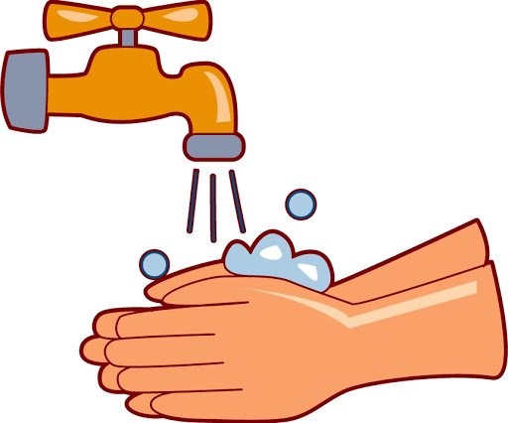

APPENDIX C – COVID-19 HEALTH SCREENING FORM
Employee Version
Employee name: _____________________________________________________
Title: _______________________________________________________________
Supervisor's name: ____________________________________________________
Have you had any of the symptoms consistent with the COVID-19 below in the last 14 days?
Symptoms | Y/N
  - Fever (subjective or 100.4 degrees Fahrenheit) or chills
  - Cough
  - Congestion
  - Sore throat
  - Shortness of breath or difficulty breathing
  - Diarrhea
  - Nausea or vomiting
  - Fatigue
  - Headache
  - Muscle or body aches
  - New loss of taste or smell
  - Or otherwise feeling unwell.

Have you been in close contact with a person who has COVID-19 in the last 14 days?
YES / NO

Date | Body Temperature | Respiratory Symptoms? | Screened by
If an employee's body temperature is at or above 100.4 degrees Fahrenheit, the employee must be sent home immediately and the following completed:
Date the employee was sent home: ____________
Recorded temperature: _____________
Are visible signs of respiratory illness present? _____ Yes _____ No

An employee sent home with a fever can return to work when:
- He or she has had no fever for at least three days without taking medication to reduce fever during that time; AND
- Any respiratory symptoms (cough and shortness of breath) have improved; AND
- At least ten days have passed since symptoms began.

The employee may return to work earlier if a doctor confirms the cause of the employee's fever or other symptoms is not COVID-19 and provides a written release for the employee to return to work.

Date the employee returned to work: _____________________

COVID-19 HEALTH SCREENING FORM
Student Version
Student Name: _____________________________________________________
Program of Study: ___________________________________________________

Have you had any of the symptoms consistent with the COVID-19 below in the last 14 days?
Symptoms | Y/N
  - Fever (subjective or 100.4 degrees Fahrenheit) or chills
  - Cough
  - Congestion
  - Sore throat
  - Shortness of breath or difficulty breathing
  - Diarrhea
  - Nausea or vomiting
  - Fatigue
  - Headache
  - Muscle or body aches
  - New loss of taste or smell
  - Or otherwise feeling unwell.

Have you been in close contact with a person who has COVID-19 in the last 14 days?
YES / NO

Date | Body Temperature | Respiratory Symptoms? | Screened by
If a student’s body temperature is at or above 100.4 degrees Fahrenheit, the student must be sent home immediately and the following completed:
Date the student was sent home: ____________
Recorded temperature: _____________
Are visible signs of respiratory illness present? _____ Yes _____ No

A student sent home with a fever can return to campus when:
- He or she has had no fever for at least three days without taking medication to reduce fever during that time; AND
- Any respiratory symptoms (cough and shortness of breath) have improved; AND
- At least ten days have passed since symptoms began.

The student may return to the campus earlier if a doctor confirms the cause of the employee's fever or other symptoms is not COVID-19 and provides a written release for the student to return to the campus.

Date the student returned to the campus: _____________________

